Module 4 Project:
ALY6110 - Data Management and Big Data
Group 12
Qiu ChenHao & Dev Panchal
5/15

Introduction
This project analyze Seattle Police Department 911 Call Data. Seattle Police Department 911 Call Data from the City of Seattle Open Data Portal. The dataset has 5.2 million rows and 17 columns covering calls from 2001 to present. Key columns include call timestamp, incident type, priority level, police beat location, precinct, and resolution status. We selected this dataset because it has real-world government data with over 5 million rows, meets the project requirements, and can answer meaningful questions about emergency services. The 20-year timespan allows for trend analysis across different times and incident types.
For this project ,there are two main business problem that we focus on first is can we use this information to accurately predict the Seattle police initial response time ? Second is how do call volumes vary by time of day, day of week, and incident type? To solve this business problem ,we plan to first use EDA to initially understand the entire dataset then use accordingly predictive model to address each problem
Tools used for project
Visualization
- Tableau
- PowerBI
Predictive model and analytics
- Google Collab
- Jupyter Notebook
Visualization 1
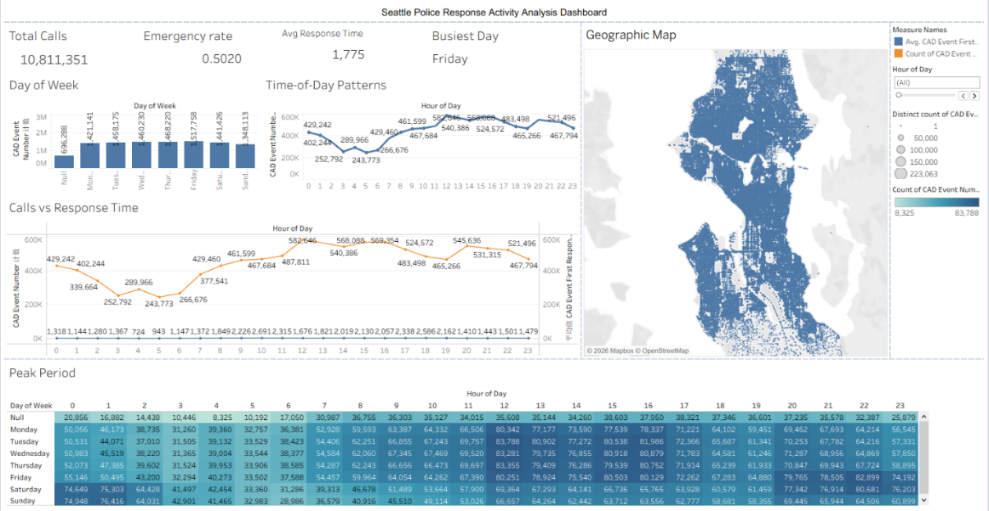
In order to further understand the dataset that our groups selected in week 3 .I generated a dashboard containing 5 different graphs .Each focusing on a different aspect of the dataset .Plot 1 focuses on the number of cases happening everyday of the week .From this visualization we can see that the CAD event count shows an increasing trend starting from Monday to Friday and reaching its peak on Friday. Friday receives the most calls, which seems reasonable since Friday is when people tend to have more free time and release their stress. Therefore, security problems will increase significantly
The second visualization plot is a line graph describing the CAD event number over time .From this graph we can see that lowest call volume happens during the early morning between 3 am and 6 am .As time passes , CAD events start to increase and by 12 pm, the CAD event count reaches its peak .After 12pm,the CAD number will vary within a specific range and start to decline starting from 10 pm , reaching the lower limit again. This line chart clearly shows that the CAD event number is closely related to daily human activity cycles which means that high human activity levels will cause more CAD event.
The third visualization is a dual axis chart that tests the relationship between CAD event numbers and CAD initial response time. Base on the plot ,we can see that as call volume increases, there is also an increase in average response time .This pattern can also be observed when the CAD event number is lower ,the average CAD first response time will also be lower .This result indicates that there is a positive correlation between event number and response delay.
The fourth visualization is a heatmap based on time of day and weekdays .This plot combines both weekdays and time-of-day data together to identify the time periods on specific days that have largest and lowest numbers of CAD events. According to the heatmap, apart from null values Tuesday at 12pm has the largest CAD event number and Sunday at 6am has the lowest. With this heatmap ,the Seattle police department can revise the staff work schedules to avoid understaffing or overstaffing.
The last visualization is a geographic map that records the exact location of every CAD event took place ,Base on the map we can see that CAD events are clustered in central urban areas and has a sparsely distributed in outer regions .We can conclude that the CAD event number is directly related to population density and activity concentration a higher population density correspond to a higher possibility of a CAD event. This result will help the Seattle police department to allocate more officers to places that have a high possibility of CAD events.
This dashboard gives the audience an idea that CAD events are most likely to occur on weekdays during afternoon hours and in central urban area. Outer regions have a significant lower likelihood of CAD events than urban areas. At the same time, as the CAD event count increases ,police officers will need more time for CAD first response.

Visualization 2
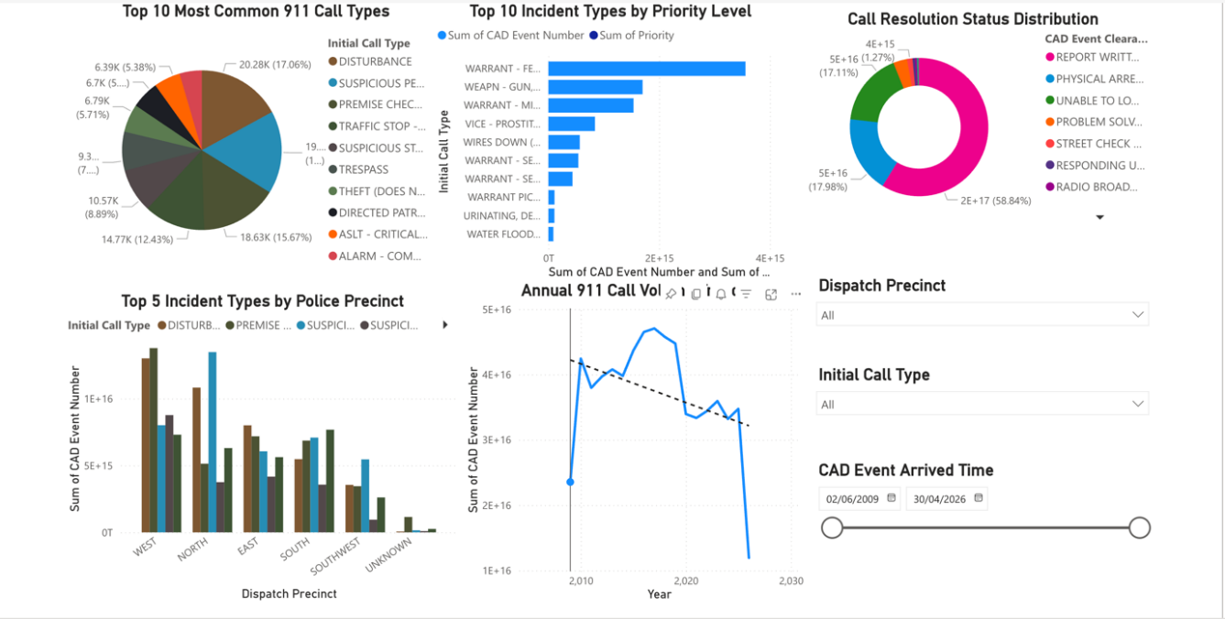
In order to further understand the dataset that our group selected in week 3, I generated a dashboard containing 5 different graphs. Each focusing on a different aspect of the dataset. Plot 1 focuses on the most common types of 911 calls received by the Seattle Police Department. From this visualization we can see that disturbance calls represent the largest portion at nearly 18%, followed by suspicious person reports at around 16%. This pattern makes sense because disturbance calls include arguments, noise complaints, and public disruptions which are common in a dense urban environment like Seattle. Understanding which incident types consume the most police resources helps the department allocate officers and training appropriately. If disturbance calls represent such a large percentage, officers need strong de-escalation and conflict resolution skills.
The second visualization plot is a stacked bar chart describing how different incident types are classified by priority level. From this graph we can see that certain incident types like warrant calls receive consistently high priority classifications, while others like property crimes or parking violations receive lower priorities. As call priority increases, dispatch sends officers more quickly and may send multiple units. This pattern can also be observed when looking at weapon-related calls which almost always receive high priority status. This result indicates that the dispatch system successfully differentiates between emergencies requiring immediate response and less urgent matters that can be handled with more flexible timing. With this information, the Seattle police department can ensure adequate staffing to handle high-priority incidents without neglecting lower-priority calls that still require attention.
The third visualization is a donut chart that shows how 911 calls are ultimately resolved. Based on the plot, we can see that report writing without arrest represents the largest category at nearly 59%, followed by physical arrests at around 18%. This distribution reveals important information about police workload and effectiveness. A high percentage of report-writing outcomes means officers spend significant time on administrative documentation after responding to calls. Physical arrests represent cases where criminal activity was confirmed and suspects were taken into custody. The unable to locate category at 11% indicates situations where the problem had resolved or could not be confirmed by the time officers arrived. Understanding these resolution patterns helps evaluate whether response protocols are effective and whether resources are being deployed efficiently.
The fourth visualization is a clustered column chart based on police precincts and incident types. This plot combines both geographic location and incident categories together to identify which precincts face which types of challenges. According to the chart, the West precinct which covers downtown Seattle experiences significantly higher volumes of disturbances and suspicious person calls compared to other precincts. The North and East precincts show more balanced distributions across different incident types. This geographic variation makes sense because the West precinct includes the commercial core with more nightlife, retail activity, and transient populations. With this information, the Seattle police department can allocate more officers to the West precinct and provide specialized training for the types of incidents that occur most frequently in each area.
The last visualization is a line chart that records the total number of CAD events over time from 2010 to present. Based on the chart we can see that 911 call volumes increased steadily through the 2010s, reaching a peak around 2020 with over 400,000 calls per year. After 2020, there is a significant decline in call volumes, dropping to around 200,000 calls by recent years. We can conclude that this pattern likely reflects multiple factors including the COVID-19 pandemic, changes in policing practices, and shifts in how communities utilize emergency services. The trend line shows an overall downward direction in recent years. This result will help the Seattle police department plan for future staffing needs and budget allocations based on actual demand rather than outdated assumptions about continually increasing call volumes.
This dashboard gives the audience an idea that disturbances and suspicious person calls are the most common incident types in Seattle, that high-priority calls receive faster dispatch, that most calls result in report writing rather than arrests, that the West precinct experiences the highest call volumes, and that overall demand has declined significantly since 2020. The dashboard also includes three interactive filters that allow users to examine specific time periods, precincts, or incident types. These filters make the dashboard a flexible tool for ongoing analysis rather than just a one-time report. At the same time, the dashboard complements my teammate's analysis of temporal patterns and response times to provide a complete picture of Seattle's emergency response operations.
Data Cleaning
In order to further understand the relationships that exist inside the dataset, we need to use a model to further investigate.
Before start to build the model, we need to first to clean up the data source, since it’s a 5.5GB large dataset. A normal read-in method is not useful in this case. We split the dataset into several chunks and read them, this will significantly increase processing efficiency. After extracting the entire dataset, duplicate records were removed to prevent them from biasing the model. For records that are missing important data such as timestamps and call classifications ,they will be removed, as they won’t have any effect on estimating call response time in the future ,For records that have no call classification I will insert an unknown type instead for consistency. At the same time all timestamps will be transformed into a uniform time format which is easier for the models to read and analyze. Outliers will also be excluded in this step to reduce their impact on the estimation.
Random forest Model
After completing these data cleaning and filtering steps, we start to build the model .The model I used is a Random Forest Regression model, its target variable is Response_Time_Minutes ,and the variables that will be used to predict the target variable include Initial Call Type, Final Call Type, Priority, Time-related variables and Clearance Description. Random Forest can effectively handle nonlinear relationships and performs better when dealing with real-world datasets. It uses multiple decision trees initially then averages their predictions in order to improve result stability and accuracy.
For the training and testing of this model I split the dataset into 2 parts.80% for training and 20% for testing. The training part is used to let the model understand the relationships between operational factors and police response time. The testing part is used to validate whether the relationship the model learns is accurate or not. I used a fixed number of random_state value to ensure reproducibility of the results. After the model produces its result, its performance will be shown in MAE,RMSE and R^2 scores The results of the model are shown below:
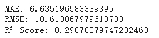
This result shows that the predictions that the model produces are approximately 6–7 minutes away from actual response times, The RMSE value is about10.60 suggesting that while most predictions were reasonably accurate, but there are still some large prediction errors l present.,R^2 shows that this model can explained approximately 29% of the variation in police response times. Although R^2 is just about 30% it’s still a somewhat reasonable result .This dataset is an officially released dataset that may have important real-world factors hidden from the public, which could allow the model to perform better. Apart from these three metrics I also generated an importance table of these factors and generated a visualization base on that
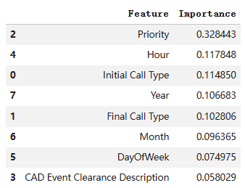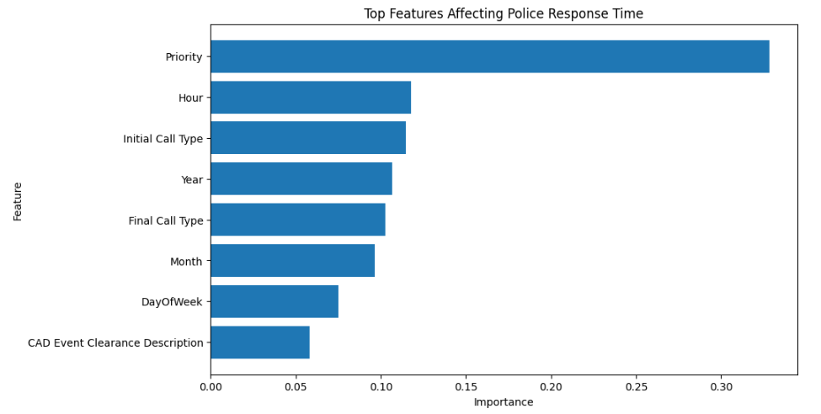
We can see that from this model that priority has the largest importance of all factors, it’s three times more important than second most important factor. Other factors have similar importance.

In conclusion for this model, it first indicate that using historical dispatch information ,it’s possible to use a model to predict the response time of Seattle police, even though it is not accurate enough. It also points out that priority is the main factor that affects the response time .These kind of results might help police to deeply understand the response time model, and predict high-delay period .
Another point that this result tells us is that there are still several limitations in public dataset ,some factors like officer availability, are missing, otherwise accuracy can be further improved .To further improve this result ,I suggest including external data sources, implementing advanced boosting algorithms, and using real-time forecasting models.
Model 2
After my partner built the Random Forest model for response time, I created a second model with a different purpose. The model I used is a Decision Tree Classifier model. Its target variable is Priority_Binary, which I created by grouping Priority levels 1-2 as High Priority and Priority levels 3-5 as Low Priority. The variables that will be used to predict the target variable include Initial Call Type, Dispatch Precinct, and Hour. Decision Tree works by creating decision rules that split the data to classify calls into high or low priority categories.
For the training and testing of this model I split the dataset into 2 parts. 80% for training and 20% for testing. The training part is used to let the model learn which call characteristics indicate high versus low priority. The testing part validates whether the model learned correctly. I used stratified sampling to keep the same proportion of High and Low priority calls in both sets. I used a fixed random_state value to ensure the results can be reproduced. After the model produces its result, its performance will be shown in Accuracy, Precision, Recall and F1-Score.
The model performance results are shown in the visualization below. The model achieved 86.57% overall accuracy, meaning it correctly classified 86.57% of all test cases. As shown in the confusion matrix graph in the top left, out of the test data, 30,750 High Priority calls were predicted correctly and 4,774 were predicted incorrectly as Low Priority. For Low Priority calls, 30,672 were predicted correctly and 4,754 were predicted incorrectly as High Priority. The Precision, Recall and F1-Score are all 0.87 for both classes. The bottom left graph shows the actual versus predicted distribution, confirming that the model predictions closely match the real data. The large accuracy number displayed in the bottom right (86.6%) summarizes the overall performance.
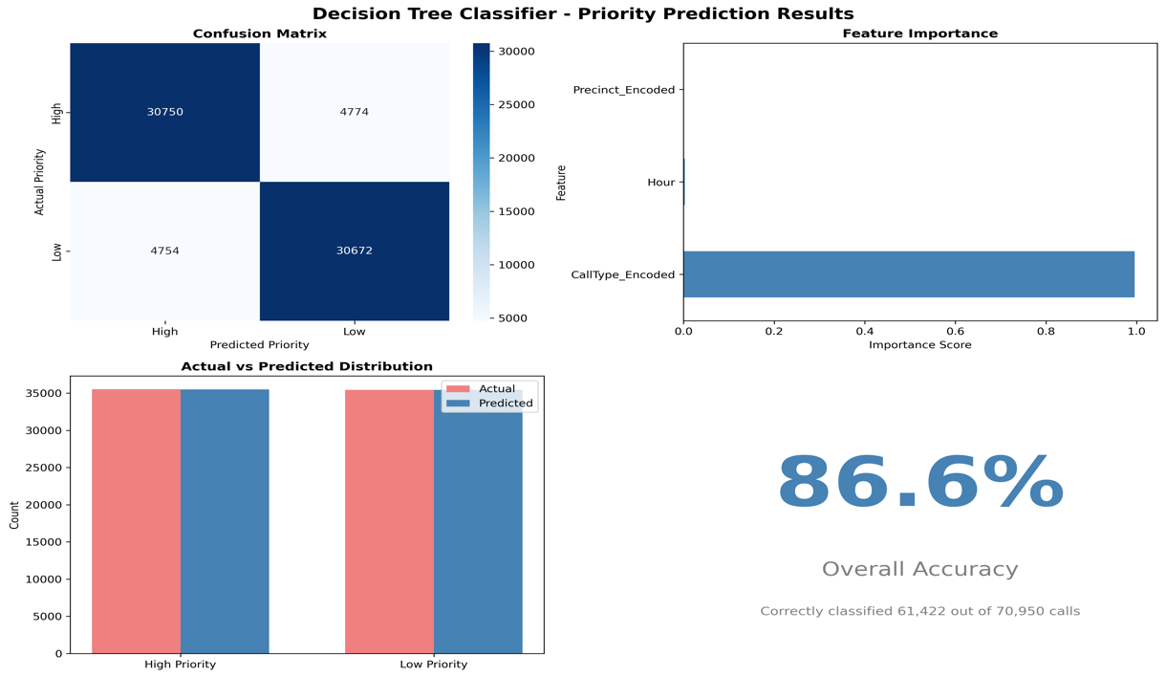
Apart from accuracy metrics, I also analyzed which features are most important for prediction. The feature importance graph in the top right shows that Initial Call Type completely dominates with an importance score of 0.9959. This means Call Type accounts for 99.59% of the model's predictive power. Hour has only 0.0030 importance and Precinct has only 0.0011 importance. We can calculate that Call Type is 336 times more important than Hour. The horizontal bar chart clearly visualizes this massive difference, with the Call Type bar extending almost the full width while Hour and Precinct bars are barely visible.
This extreme dominance of Call Type makes sense when we think about real dispatch operations. A call about a WEAPON or ASSAULT will always be high priority no matter what time it is or where it happens. A call about PARKING or NOISE will always be low priority regardless of location or hour. The incident type fundamentally determines urgency. Time and location have almost no effect on priority classification.
In conclusion for this model, it shows that call priority can be predicted with 86.57% accuracy using just three simple features available when a call first comes in. The strong performance means this model could be deployed in real dispatch centers to automatically pre-classify incoming calls. This would help dispatchers handle urgent emergencies faster while managing routine calls efficiently. The model reveals that Call Type alone is sufficient to predict priority in most cases.
One limitation is that the model only uses three features. Adding more variables like caller history or specific address details might improve accuracy further. However, 86.57% is already high enough to be useful. Another limitation is that the model learned from historical data where humans assigned priority, so it may repeat any biases from past decisions. To improve this model, I suggest testing with more features and validating on recent data to ensure it stays accurate as patterns change.
Conclusion
This project successfully analyzed Seattle 911 call data to understand patterns and build predictive models for emergency response optimization. We answered our two main business questions about predicting response time and understanding call volume patterns through dashboard analysis and machine learning models.
Our analysis revealed six key findings. First, temporal demand is predictable. Calls peak Friday afternoons and midday, dropping sharply in early morning. This pattern enables optimized officer scheduling. Second, geography mirrors population density. West precinct generates the most calls, allowing evidence-based patrol allocation. Third, my Decision Tree model shows that Call Type predicts priority with 86.6% accuracy. Call Type is 336 times more predictive than other factors. WEAPON and ASSAULT calls are almost always high priority while PARKING and NOISE are almost always low priority. Fourth, response time is load-dependent. The positive correlation between call volume and response time confirms that resource strain during peak hours causes delays. Fifth, my partner's Random Forest model shows Priority dominates response time prediction, being 3 times more predictive than any other factor. Sixth, the two models create a complete picture. Decision Tree classifies call urgency with 86.6% accuracy. Random Forest predicts response time. Together they enable proactive dispatch optimization.
When comparing both models, they serve complementary purposes rather than competing with each other. The Decision Tree answers whether a call is urgent or routine. The Random Forest answers how long response will take. Neither model is better because they solve different business questions. The Decision Tree has higher accuracy at 86.57% but this measures classification performance. The Random Forest has R-squared of 0.29 but this measures regression performance. These metrics cannot be directly compared. What matters is both models perform well enough for practical deployment.
The combined system provides complete decision support for dispatchers. When a 911 call comes in, the Decision Tree automatically predicts priority based on call type. Then the Random Forest estimates response time using that priority prediction plus other available information. Dispatchers immediately know both how urgent the call is and approximately how long response will take. This enables better resource allocation and realistic caller expectations.
Based on our findings, we recommend six actions for Seattle Police Department. First, optimize officer scheduling to match demand patterns, staffing more during peak periods like Friday midday and reducing overnight coverage. Second, concentrate additional resources in West precinct where call volumes are highest. Third, invest in de-escalation training since most calls end in report writing rather than arrests. Fourth, implement priority-aware dispatch routing that accounts for current queue depth. Fifth, expand the dataset with officer availability and traffic data to improve prediction accuracy. Sixth, plan staffing for continued call volume decline to avoid overstaffing.
This project demonstrates that big data analytics can improve public safety operations. By analyzing millions of historical 911 calls and building two machine learning models, we identified actionable patterns and created tools that could be deployed in real dispatch centers. The dashboards provide visual insights into call patterns while the models enable automated predictions. Future work could test these models in live dispatch environments, incorporate additional data sources, and measure actual impact on response times and public safety outcomes.
Data Set Link:
https://data.seattle.gov/Public-Safety/Call-Data/33kz-ixgy/about_data

